

User Acceptance Testing (UAT) Template
Date : 18 February 2026
Team ID : LTVIP2026TMIDS84411
Project Name : ShopEZ: One-Stop Shop for Online Purchases

Maximum Marks: 2marks

Project Overview
Project Name: ShopEZ
- Project Description: ShopEZ is a full-stack e-commerce web application built using the MERN stack (MongoDB, Express.js, React.js, Node.js). It provides a seamless online shopping experience for users and a robust admin dashboard for sellers to manage inventory and orders2.
- Project Version: v1.0.0
- Testing Period: February1, 2026 – February 15, 2026

Testing Scope

Features and Functionalities to be Tested:
  - User registration and login
  - Product browsing and filtering
  - Shopping cart management
  - Secure checkout and payment flow
  - Order tracking
  - Admin inventory and order management
  - Responsive UI across devices



User Stories / Requirements to be Tested:
  - As a user, I want to register and log in securely.
  - As a user, I want to browse and search for products.
  - As a user, I want to add/remove items from my cart.
  - As a user, I want to complete a purchase with secure payment.
  - As an admin, I want to manage product listings and view orders.

Testing Environment
- URL/Location: http://localhost:3000/api/products
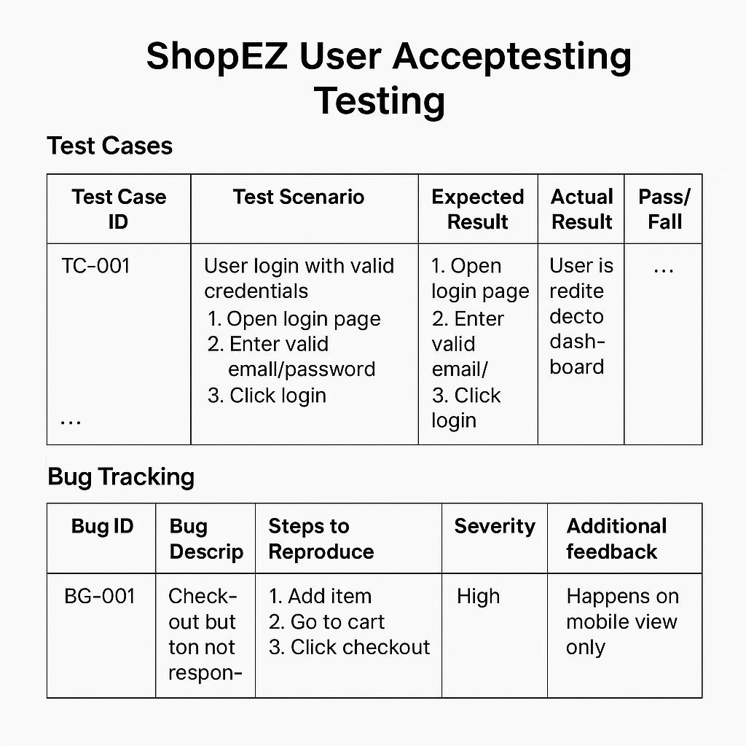

Sign-Off Details
- Tester Name: M.Bhagya laxmi
- Date of Test Completion: 18th February 2026
- Signature: M.Bhagya Laxmi



Final Notes
- All test cases have been executed, covering both positive and negative scenarios.
- Testers have provided detailed feedback, including usability suggestions and enhancement ideas.
- Bug tracking includes:
  - Severity levels (Low, Medium, High, Critical)
  - Status (Open, In Progress, Resolved, Closed)
  - Clear steps to reproduce each issue
- All critical and high-severity bugs have been resolved or mitigated.
- Sign-off approval is required from:Project Manager,Product Owner

